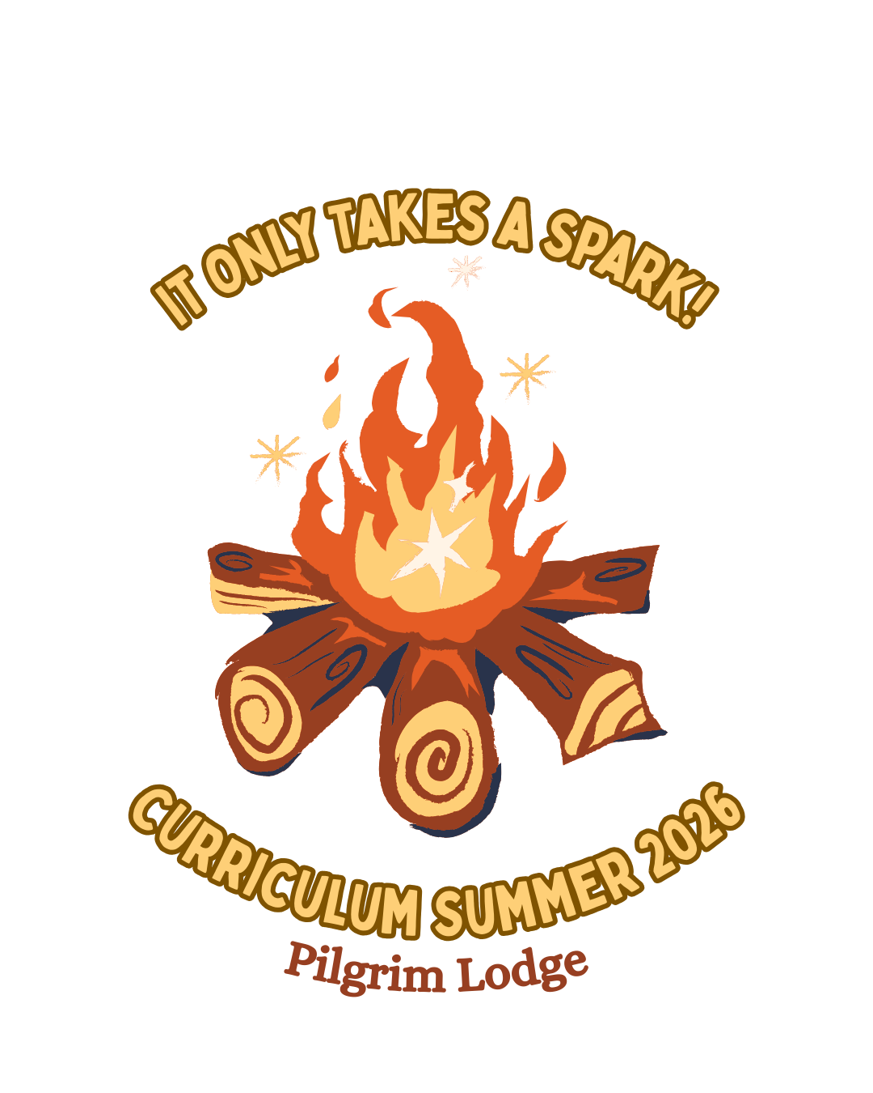

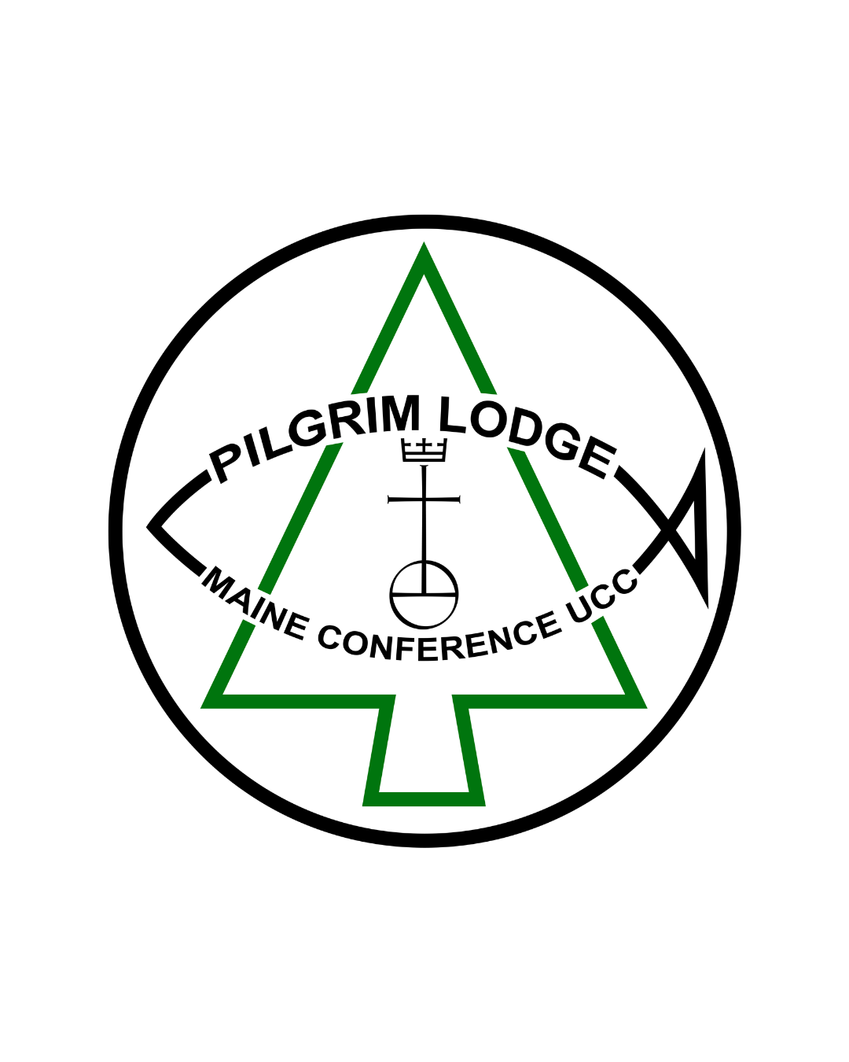

It only takes a spark… and some kindling, firewood, patience, attention, and a bucket of water to keep us all safe at the end of the night. Building a campfire is a lot like building a community. Together, we bring our whole selves into sacred, shared space to gather what we need to warm our hearts and our bodies, to find light for the journey before us. It takes the spark in each of us to ignite the fire of community.
This summer, we are building community like a campfire.
Will you bring the firewood? Will you bring the kindling?
Will you bring your spark?
Our theme for the summer of 2026 is, “It Only Takes A Spark" inspired by the lyrics of the beloved camp song, “Pass It On”. We'll practice finding the spark inside of each of us. We will gather sticks for kindling and we will gather voices to sing. We will carry logs of firewood and we will carry one another.
This year, our camp curriculum is written by the Pilgrim Lodge community, for the Pilgrim Lodge community. The activities, stories, big questions, and programmatic content in this curriculum have been written especially for PL campers. Throughout our time at camp together, we’ll focus on themes of belonging, wonder, identity, courage, and community.
Camp is a place where new perspectives are formed, stories are woven together, and Spirit and spark come alive in each and every one of us when we come together as a community. Gathered together at camp and gathered together around the campfire, we’ll keep the fire glowing bright in all of us.
All who come in love have a seat around the campfire. You need not come with the whole campfire ready in your suitcase. You need only a spark of excitement, of curiosity, of hope, of wonder.
It only takes a spark! Will you bring yours?

Day 1: WISH
I Wish For You My Friend,
This Happiness That I’ve Found
Day 2: GLOW
Soon All Those Around,
Can Warm Up In Its Glowing
Day 3: BLOOM
The Flowers Start Their Blooming
Day 4: SHOUT
I’ll Shout It From The Mountain Tops
Day 5: PASS IT ON
We want to Pass it On!

Day 1: WISH I Wish For You My Friend, This Happiness That I’ve Found

Objective: Campers will know that they are special and unique and that our community wouldn’t be the same without them.

Story: Luke 5:1-11 Jesus' Diverse Disciples, The Book of Belonging

Day 2: GLOW Soon All Those Around, Can Warm Up In Its Glowing

Objective: Campers will build understanding and empathy for the world around them, exploring how they are connected and important to the world beyond just their own self.

Story: John 6:1-14 More Than Enough For All, The Just Love Story Bible

Day 3: BLOOM The Flowers Start Their Blooming

Objective: Campers will begin to recognize and celebrate their most authentic selves.

Story: Psalm 139:13-14 Song of Wonder, The Peace Table

Day 4: SHOUT I’ll Shout It From The Mountaintops

Objective: Campers will deepen their courage to be agents of holy change in their communities.

Story: Matthew 5:1-11 How Blessed We Are, The Just Love Story Bible

Day 5: PASS IT ON We Want To Pass It On

Objective: Campers will prepare to leave camp with a charge to go out and change the world!

Story: John 21:1-12 Jesus Lives in Us, The Just Love Story Bible

